

project report
Airline delay Data analization
Subject:
Intro to data science
Submitted By:
Saqib Asif
Instructor :
Bilal Ahmad raza

Submitted date 02 dec2025

Department of Data science University of kotli

Introduction
Airline delays are a significant challenge for both passengers and airline companies. Delays cause financial losses, disrupt schedules, and reduce customer satisfaction. Analyzing airline delay patterns helps identify key factors affecting arrival and departure delays, such as weather conditions, airline performance, airport congestion, and seasonal trends. This report presents a detailed examination of delay patterns based on a sample airline dataset.
Objective
- The main objectives of this analysis are:
- To understand overall airline delay trends.
- To identify variables that significantly contribute to departure and arrival delays.
- To explore patterns, correlations, and seasonal behaviours in flight delays.
- To generate insights that can help improve operational efficiency and reduce delay frequency.
Dataset Description

The dataset typically includes U.S. domestic airline flight information for a particular year. Common attributes include:
Date/Time Variables: Year, Month, Day of Month, Day of Week.
Flight Information: Airline carrier, Flight number, Tail number.
Data Cleaning and Preprocessing
To ensure accurate analysis, the following steps are performed:
Handling Missing Values :
Removed rows with missing key delay fields.
For weather or cancellation reasons, imputed missing values using “0” or “Unknown” categories where appropriate.
Removing Duplicates:
Checked for duplicate flight records and removed them.
Data Transformation:
Converted date/time columns into proper datetime format
Extracted additional features: Hour of day, Season, Weekend indicator.
Outlier Treatment: Extremely high delays (e.g., > 24 hours) identified and filtered or capped.
Encoding Categorical Variables:
Airline, Origin, Destination converted using label or one-hot encoding (if required for modeling).
.Exploratory Data Analysis (EDA):

Delay Distribution
Arrival and departure delays show a right-skewed distribution.
Most flights leave within ±10 minutes of the scheduled time.
A small percentage contributes to large delays (>60 minutes).
Airline-wise Delay Pattern
Some airlines consistently show lower delays, indicating efficient operations.
Others have higher delay averages due to network size, connection frequency, or airport hubs.
Airport-wise Congestion
Major hubs like ATL, LAX, ORD, JFK show higher delays due to traffic volume.
Smaller airports generally show lower average delays.
Time-of-Day Trends
Early-morning flights are less likely to be delayed.
Route & Airport Codes: Origin, Destination.
Time Data: Scheduled Departure/Arrival, Actual Departure/Arrival.
Delay Fields: Departure Delay (DepDelay), Arrival Delay (ArrDelay).
Other Features: Distance, Cancellation Status, Cause of Delay (Weather, Security, Airline, Late Aircraft, NAS).
Delays increase significantly during late afternoon and evening due to propagation of earlier delays.
Seasonal & Monthly Patterns
Winter months (December–February) show higher delays due to weather conditions.
Summer shows moderate delays due to busy travel season.
Correlation Insights:
DepDelay and ArrDelay have a strong positive correlation.
Weather delays strongly affect both arrival and departure delays.

Key Findings:

- Weather-related delays are more frequent in winter and during storms.
- Evening flights have the highest average delay compared to morning flights.
- Busier airports show significantly more delays due to congestion.
- Some airlines outperform others in terms of punctuality.
- Departure delay is the biggest predictor of arrival delay.

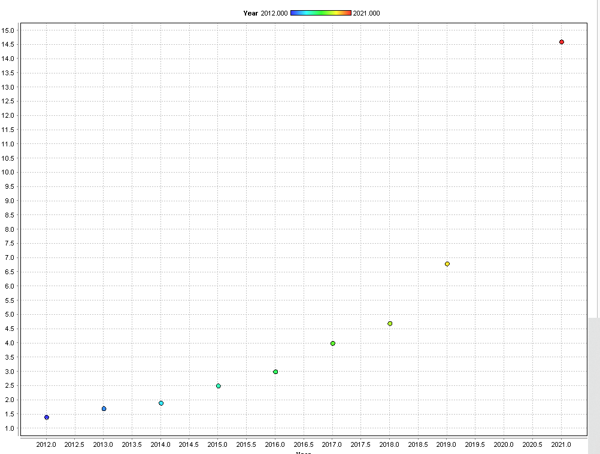

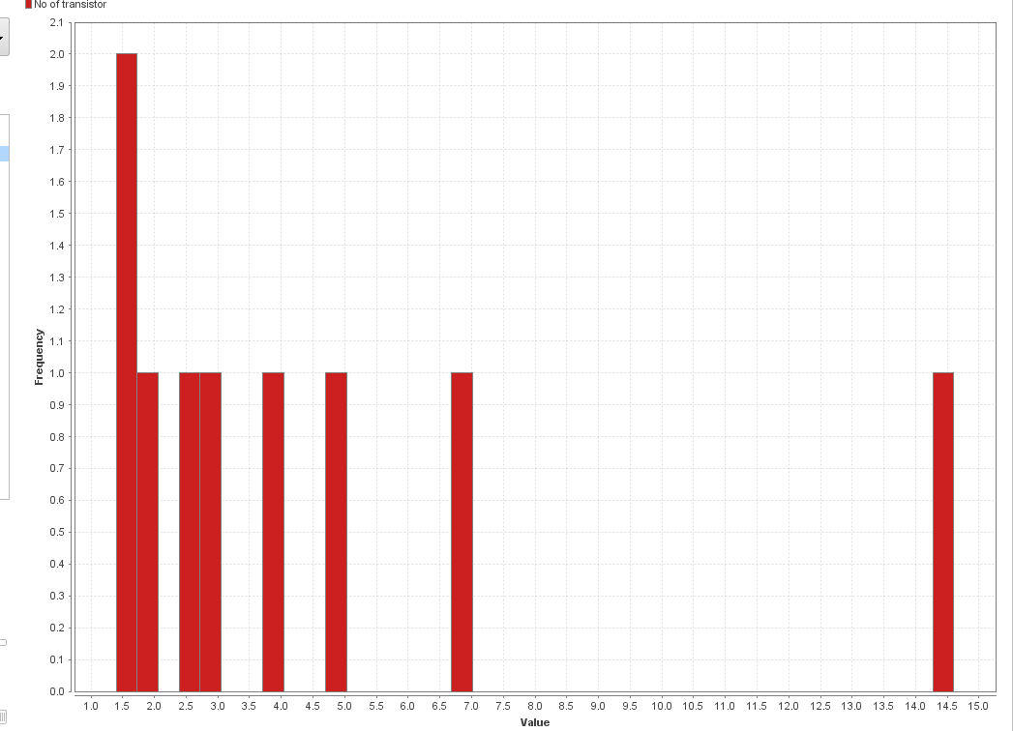
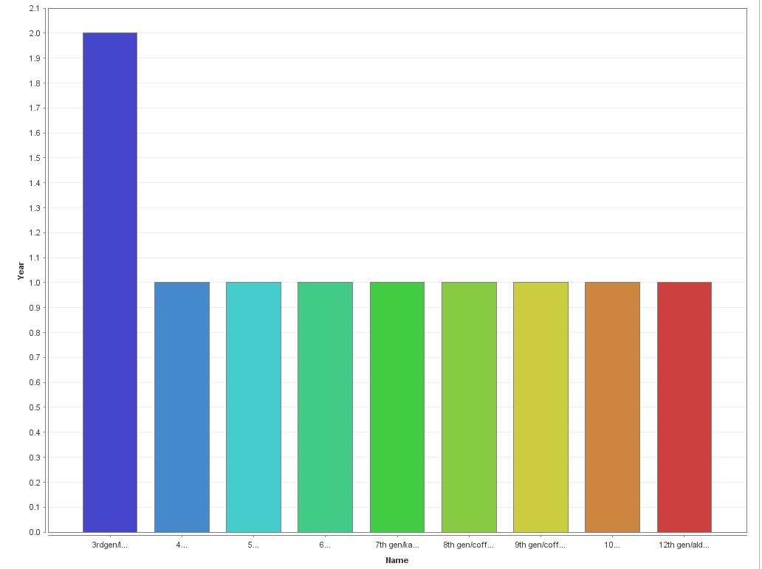
Conclusion
The analysis shows that airline delays are influenced by multiple factors, including time of day, season, weather, and airport congestion. Understanding these patterns helps airlines optimize scheduling, improve operational efficiency, and plan better for high-risk periods. Further analysis can include predictive modeling to forecast delay probability and exploring strategies to minimize recurring delay causes.

